DCS IRON
2021
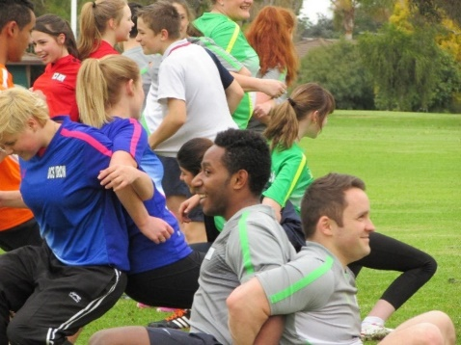
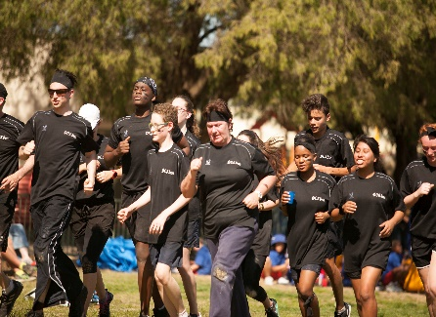
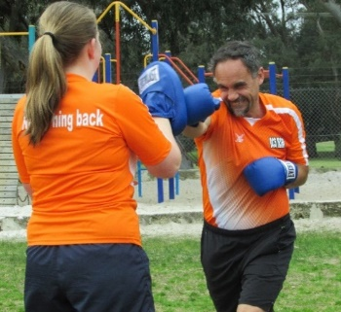

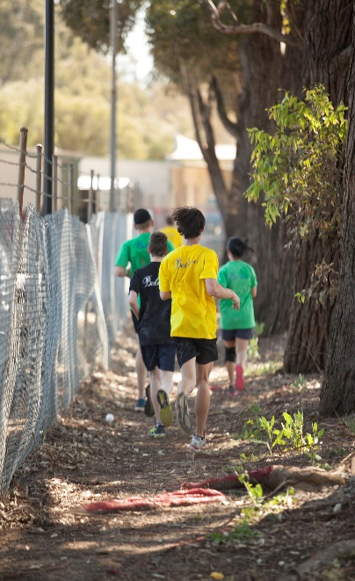

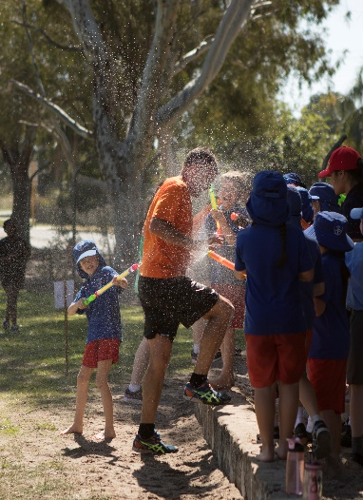
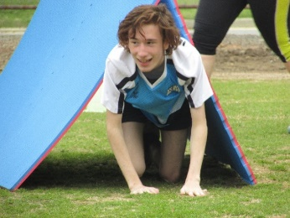
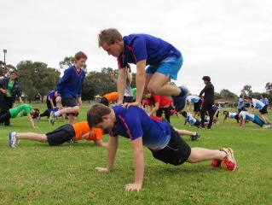

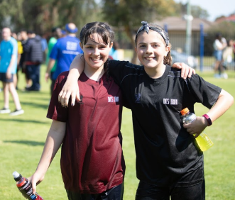
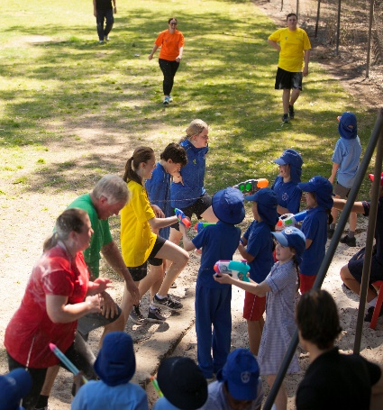

Believe

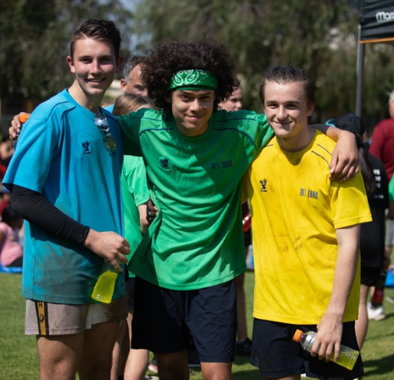

DCS IRON is 9 weeks of 6 teams participating in boot camp style fitness training, overseen by trainers/staff. It emphasizes team, personal improvement, character & spiritual development.

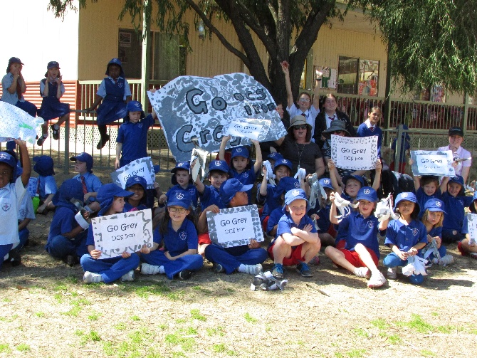

At the end of the 9 weeks, these 6 teams will face off in an endurance circuit race – the DCS IRON Event! The whole school will be watching and supporting it.
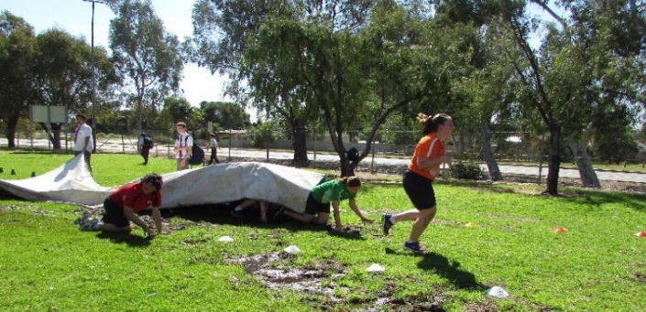

At times, you will be pushed to your limit or you may have to step up to help a team mate but jump in and enjoy – you will get a lot out of it.
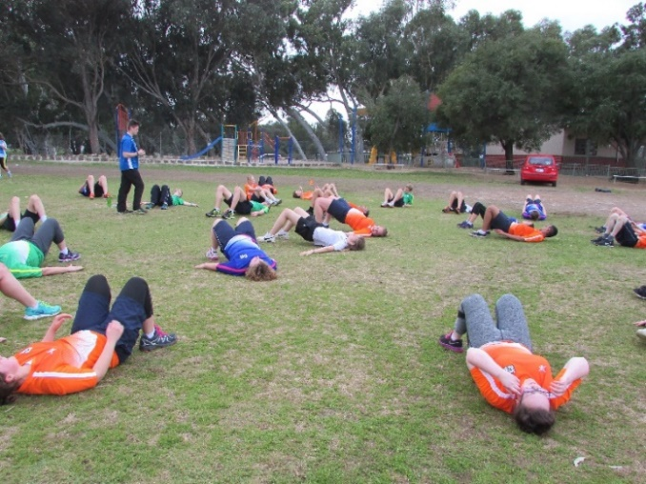
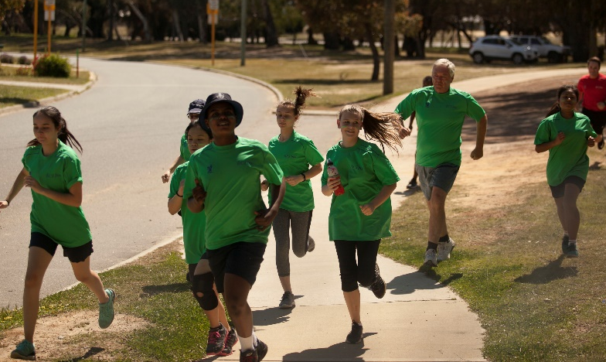

Draft Training Schedule
Week 1
Thursday 22nd July
Fitness Assessment – Beep Test etc. (Gym)

Week 2  Mon 26th July  3:25 – 4:40 | Thur 29th July  3:25 – 4:40 Personal Trainers
Week 3  Mon 2nd Aug  3:25 – 4:40 | Thur 5th Aug  3:25 – 4:40 Personal Trainers
Week 4  Mon 9th Aug  3:25 – 4:40 | Thur 12th Aug  3:25 – 4:40 Personal Trainers
Week 5  Mon 16th Aug  Zumba | Thur 19th Aug  3:25 – 4:40 Personal Trainers
Week 6  Mon 23rd Aug  3:25 – 4:40 | Thur 26th Aug  3:25 – 4:40 Personal Trainers
Week 7  Mon 30th Aug  3:25 – 4:40 | Thur 2nd Sept  3:25 – 4:40 Personal Trainers
Week 8  Mon 6th Sept  Zumba | Thur 9th Sept  3:25 – 4:40 Personal Trainers
Week 9  Mon 13th Sept  Fitness Assessment (Gym) – Beep test etc. | Thur 16th Sept  3:25 – 4:40 Personal Trainers

Week 10  Mon 20th Sept  3:25 – 4:40 | Fri 24th September  DCS IRON EVENT

DCS Iron Event Friday 24th Sept (Starts 1:30pm)

Note: On training days (Mondays & Thursdays) you are allowed to wear your DCS Iron team shirt with the rest of your regular school sports uniform!

Expectations

Attitude & Application
This program is about you and your team improving – all the while having fun. Most likely, yes, there will be people fitter than you, but this is not what it’s about. What matters is that you commit and do your best and that you encourage your team mates. Have that never give up and ‘believe’ attitude and you will be amazed at the advances you’ll make.
You are expected to turn up to every training session. You must wear your team T-shirt (this means you need to wash it between training sessions). If you have a good reason why you cannot make a training session, inform either Mr Winslade or Ms Palmer.

Personal Training
Apart from the group training sessions, you are required to do your own exercise training 2 times a week (so, including the group sessions, you would have exercised 4 times a week).
It must be continual exercise for a minimum of 20 minutes. This may be, for example, running, cycling, using a cross trainer or brisk walking. The object is to improve your cardio fitness and prepare yourself for the gruelling final iron event.

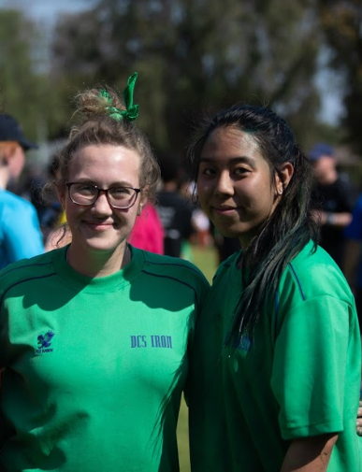
Pain Partners
You will be assigned a pain partner. This will be someone within your team. At times, an activity will be a ‘pain partner’ activity, meaning it involves two people. If your partner is unable to complete the activity, you must step up and help them by completing their unfinished section. Remember, you’re there to help your team mate out.

Example of a
Personal Training Record of __________________________
In the section below, you must write what exercise you did, date it and get your parent/ guardian to sign it as a true record. Each Thursday, Mr Winslade or Ms Palmer will check it. Points are allocated and will determine the start of your team. This can be a big advantage for your team on DCS IRON day.
Week 2 | Activity | Date | Parent Signature
Week 3 | Activity | Date | Parent Signature
Week 4 | Activity | Date | Parent Signature
Week 5 | Activity | Date | Parent Signature
Week 6 | Activity | Date | Parent Signature
Week 7 | Activity | Date | Parent Signature
Week 8 | Activity | Date | Parent Signature
Week 9 | Activity | Date | Parent Signature

Allocated Points
Team Points Determine Your Team Start Time on the Event Day
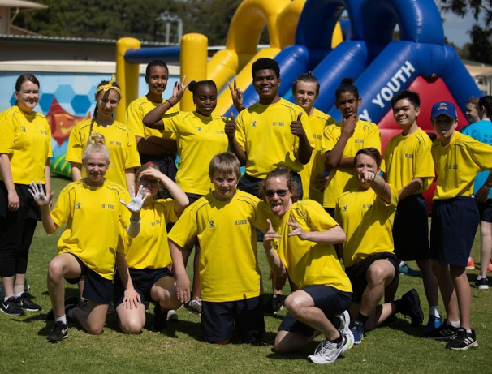
1 team point = 1 second
Team points are awarded in two ways:
- Participants are awarded 1 point if they have done their required weekly personal training (must be signed and shown on the required day)

- Trainers will award 3 points for the best effort during a training session. This will happen twice as there are two trainers.

An Example of How This Affects the Start
Before the DCS IRON Event Day, team points are tallied up and your team’s start will be determined by the difference in points between the teams e.g.
Green Team = 290 points (Gun goes off – Green starts)
Dark Blue Team = 283 points (Dark Blue leaves 7 seconds later) 290 – 283 = 7
Maroon Team = 275 points (Maroon leaves 15 seconds after the gun)
Black Team = 255 points (Black leaves 35 seconds after the gun)

The DCS IRON Event Day
While there are individual categories, this is primarily a team event.
The average competitor is required to run 5 circuits of the fence line of DCS + the school oval. Each time they do a circuit, they must pass through a number of challenging physical check points.
2 people from each team can elect to run 4 circuits. However, this means 2 people from the same team must run 6 circuits to make up the difference. Likewise, 1 team member can run 3 circuits but to balance it, 1 member must run 7!
Once you have completed the whole DCS Iron Challenge course, you go to the time recording table to record your time. The team that has the shortest combined team time wins DCS IRON! After this, you may go back and encourage a fellow team member. However, you are not allowed to physically help them; otherwise both members will incur a time penalty. Mrs Petersen is chief marshal.
Different Primary School classes will oversee certain sections of the circuit. For example, one class will be in charge of the water station, one class the chicane of pain, one class the student drag, another the water pistol step etc. This is a whole school event.
Winning Categories
- The first team to finish - team trophy + team prize
- The first across the line - trophy + prize (the first person to complete 6 circuits)
- Character - individual in each team – trophy

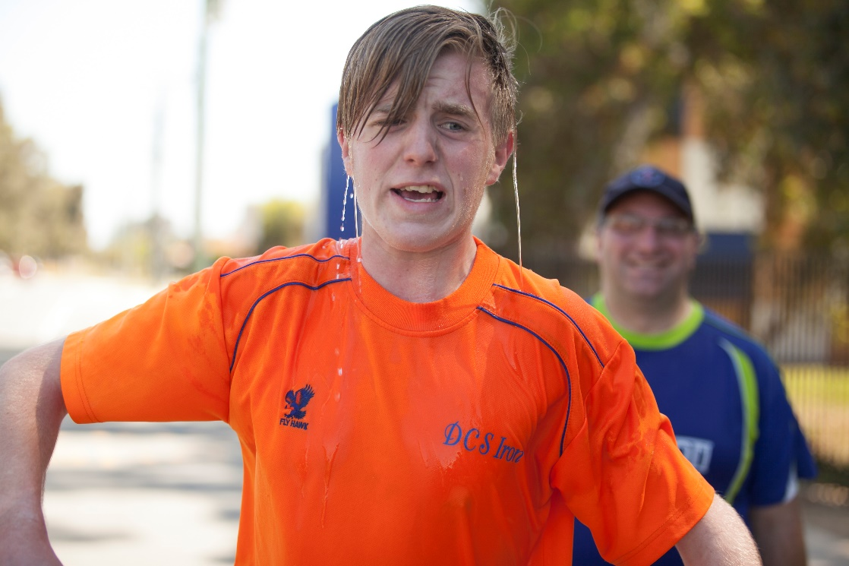

Believe

DCS IRON PERMISSION FORM

There is a cost of $50 per student to participate (family discount of $40 per child). This is for the t-shirt and to help cover the costs of our professional trainers. The payment & permission slip need to be in by Monday 14th June (Week 9). Please hand it in at the Reception. Spaces are limited (last time several people missed out).

PERMISSION
I give permission for my child (full name) ______________________________________________,
in year level _________________________ to participate in the 10 week DCS Iron program, which runs for 1 hour & 15 minutes after school form 3:30 – 4:45, every Monday and Thursday, starting Thursday Week 1, Term 3.
Signed _________________________________________ (parent / guardian)
Printed name of parent / guardian ____________________________________

Please tear this back sheet off, along with the payment, and hand into the front offcie. Keep the remaining information sheet.

